NASA
SPACE APPS CHALLENGE

Martian’s-Eye

(A device developed to atmosphere on planet mars)

Authors:

NAME | E-mail
Thanjagari Vamsi | thanjagarivamsi@gmail.com
Prathamesh Dixit | prathmeshydixit@gmail.com
Karthik Sanga | Karthiksanga121@gmail.com
Udutha Bhargav | Udutha.bhargav@hotmail.com

Challenge:
develop sensors to be used by humans on mars.

Problem:

In today’s agricultural scenario, pesticides and insecticides are becoming expensive day by day and spraying them also reduces the productivity of the farm. It is difficult for a farmer to track where a particular pest or insect attacks a plant and as a result he sprays chemicals all over the plant which may harm both plant and human health and also reduce the productivity of soil which in turn damages the economy of the farm. Spraying of such harmful chemicals has an advert effect on human health too. Most disease that spread by food are due to these chemicals sprayed on the vegetation which remains on its surface even after washing them. These chemicals are quite costly to purchase which in-turn leads to rise in the price of the grocery and affects the pockets of general public. Hence it is of dire need to find a way out to this problem.

Abstract:

In today’s agricultural scenario, pesticides and insecticides are becoming expensive day by day and spraying them also reduces the productivity of the farm. It is difficult particular pest or insect attacks a plant and as a result, he sprays chemicals all over the plant which may harm both plant and human health and also reduce the productivity of soil which in turn damages the economy of the farm. Spraying of such harmful chemicals has an advert effect on human health too. The most diseases that spread by food is due to these chemicals sprayed on the vegetation which remains on its surface even after washing them. These chemicals are quite costly to purchase which in-turn leads to a rise in the price of the grocery and affects the pockets of the general public. Hence it is of a dire need to find a way out to this problem.

To overcome this problem, our team came up with a subtle solution wherein we use Raspberry Pi and related concepts to solve this issue. We use the Raspberry Pi camera module (v 1.3) which is mounted over the device itself. We also use an object detection sensor and also a temperature sensor which is an added feature which we provide to keep a log of temperature and also hindrances.

Technological Stack:

Hardware Components:

- Raspberry Pi

- Raspberry Pi mounted camera module rev1.3

Software Components:

- ImageMagick

- Python 3 (IDLE)

- Open CV
UML Diagram and Case Study: 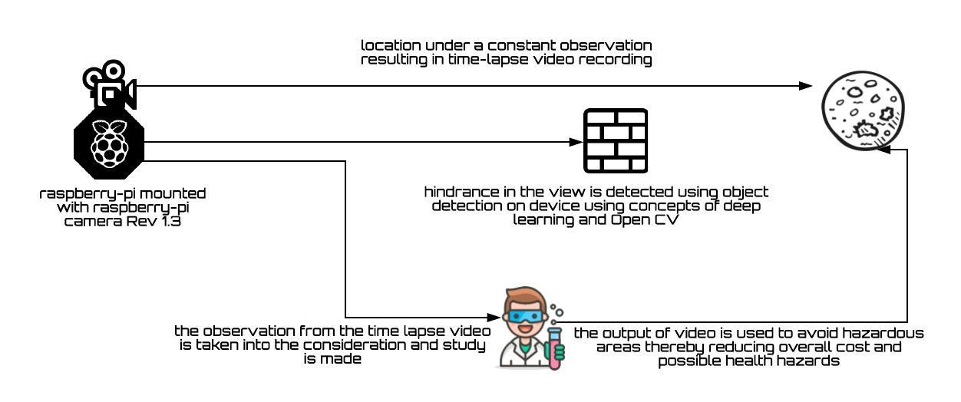

Pseudo code:

- Open IDLE (menu > programming>python3(IDLE))

- Create a new file (File>New File) and then save it as timelapse.py.

- Now with three simple lines of code, you can use Python to take a photo:

- Save your script, and then run it on your keyboard.

- You can take multiple images using the Camera Module by capturing images with a loop. A for-loop can be used to capture a set number of images.

- Modify your file to incorporate a for-loop. In this example, the Pi Camera will capture 10 images:

- Save your script again and run your program. Then have a look inside your File Manager to see what has been created.

- There’s only one image there, and it’s the last image that was

taken. This is because each image had the same file name, so it was overwritten by the next image to be taken. This is a problem which can be solved by a little modification of the script:

- If you look in the File Manager now, you should see ten images named image0000.jpg up to image0009.jpg.

- The syntax image{0:04d}.jpg adds the value of i, which starts at 0 and ends at 9, to the file name. It also pads the number with zeros, so that there are always 4 digits. This will be important later on.

- Now that you know how to take multiple photos, let’s see how you can turn that sequence into an animated GIF. For this you’re going to need the program ImageMagick. If you haven’t already installed it,

there are instructions in the software setup guide.

- ImageMagick is a command line program that can be used to manipulate images. First of all, you can try it out by opening up your terminal (ctrl+alt+t) and typing the following:

- The -delay option sets the amount of time (in 100ths of a second) between frames. The – loop option sets the number of times the GIF will loop. Here the 0 tells it to loop forever.

- This will take a little time to run, but once it’s complete you should see the file

animation.gif in the File Manager:

Reducing the file size

Currently, your animated GIF is probably sitting at around the 10MB range, which is a little large for a ten-frame animation. This is because your Pi camera captures images at a resolution of 3280 x 2464 if you have

- You can double-click this and watch the animation in Image Viewer. Again, give it a little time to open as it’s probably a fairly large file.

- As with all command line programs, you can call ImageMagick from within Python. You just need to use the OS library, as shown below:

- This will take a little time to run. You should see the word done printed in the shell when the script has finished. Your new animation.gif will be playable from the File Manager after a couple of minutes.

a Camera Module v3, or 1920 x 1080 if you have an original Camera Module. You can produce smaller GIFs by using a smaller image resolution.

- Go back to your timelapse.py file. Now add in a single new

line to set the resolution of the images:

- If you want even smaller GIFs,

then choose an even smaller resolution.

The point of time-lapse is to take pictures every few minutes or even hours. To do this you can pause your program between captures, using the time library.

Back in your file, alter the timelapse.py code so that you can import the sleep function, and then pause the script after each capture:

- In the above example a picture is taken once every 60 seconds,

Advantages:

- Pesticides now a day are quite expensive and their use is also dangerous to both flora and fauna.

and ten pictures are taken in total. You can now modify the values for the range() and sleep() functions to whatever suits your purpose. If you want to capture a flower opening, then a picture a minute for a couple of hours would suffice. If you were making a time-lapse of a fruit rotting, then two or three pictures a day might be more appropriate.

- Set up your Raspberry Pi with the Camera Module pointing at your target, run the script, and then sit back and wait for the GIF to be created.

- The ‘Martian’s-Eye’ device helps the farmers and also the pesticide making companies to study the part of plant which pests precisely attack.

- With the help of the device, only the area which is most probable to get infected is

sprayed which in turn helps in saving the pesticide usage.

- This helps in a way in which the farmer is benefited both economically and also saved from many respiratory diseases caused due to inhalation of harmful chemicals.

- The decrease in the usage of pesticides helps not only to get healthy and natural veggies but also these are made available to common people at a very low price.

Dependencies:

- To develop this device we require a Raspberry Pi device which can gain an access over a camera.

- The farmers should also be educated as to how the device shall be used and also show them various aspects involved in the process.

- The pesticide making companies shall be approached

and a detailed study should be made on various plant species to get an effective solution beforehand.

- The place where one decides to mount the device shall be kept closer to the plant and must ensure that no obstacle interferes the view of the device in order to get satisfactory result.

